CLAIM MANAGEMENT
& CLAIM COUNT ANALYTICS DASHBOARD
P&C Insurance Claims Performance in Power BI
Project Documentation
Prepared as a Data Analytics Portfolio Project
Tool: Microsoft Power BI Desktop
NOTE: The original working dataset for this report was lost. This documentation describes a reconstructed, structurally-equivalent dataset built to closely reproduce the dashboard's visible KPIs — see Section 3 for details.
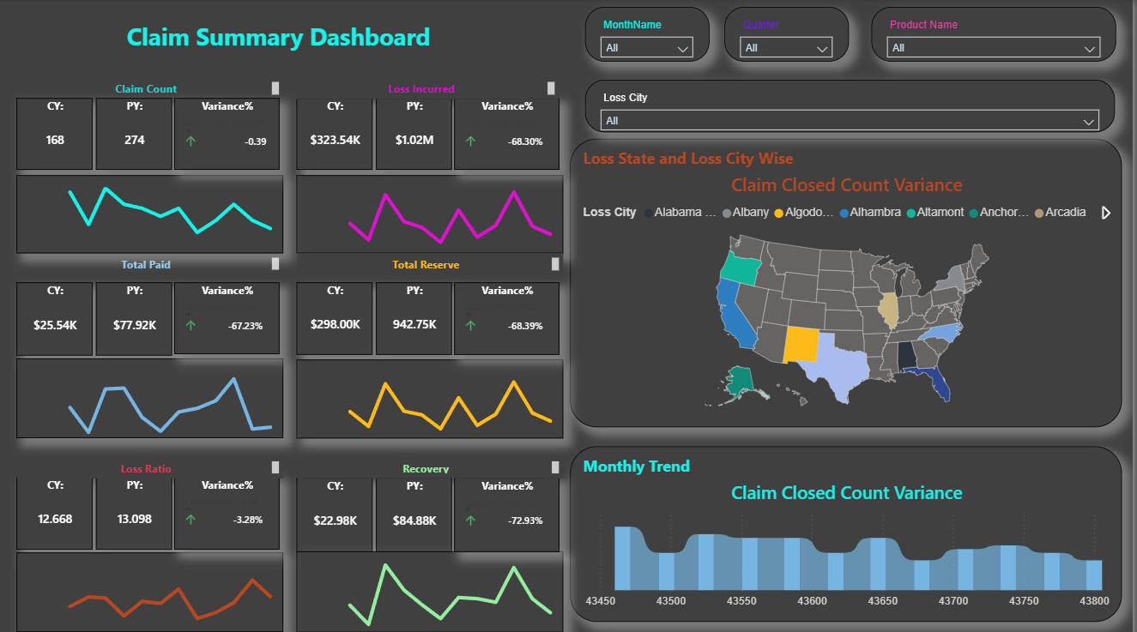
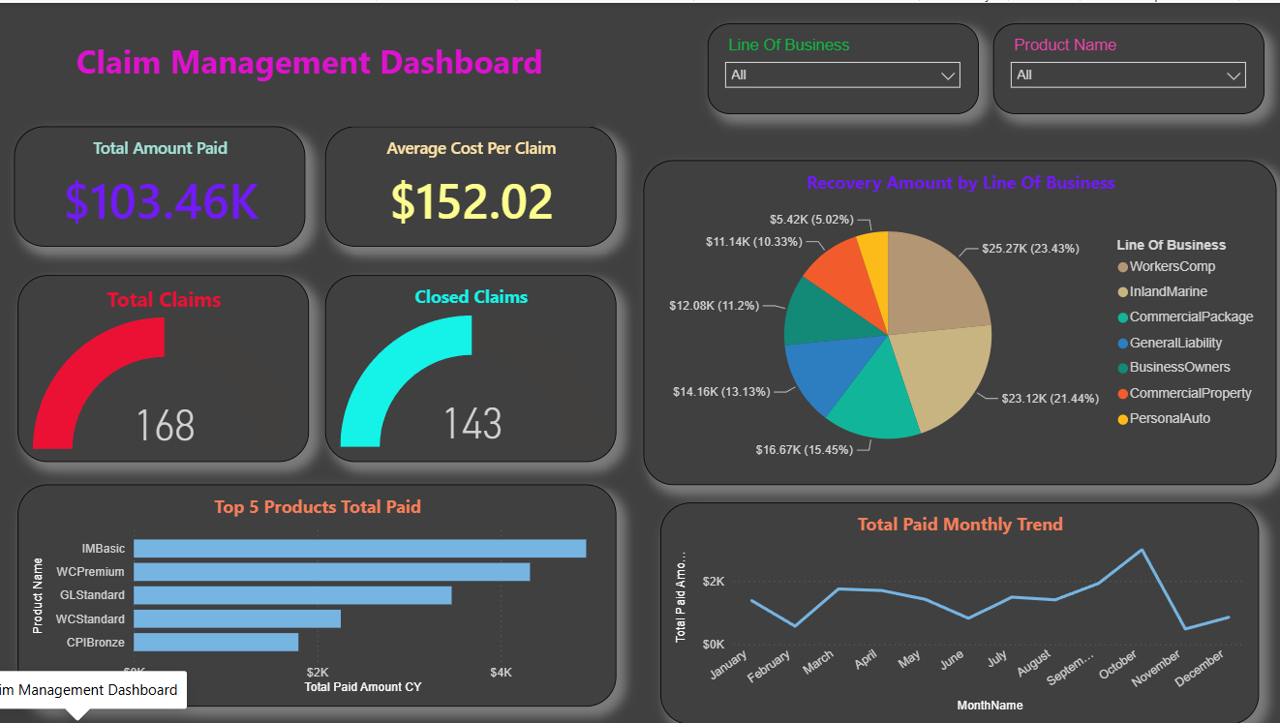

1. Project Overview
This project is a Property & Casualty (P&C) insurance claims analytics suite built in Power BI, covering claim volume, financial performance (paid, reserved, recovered amounts), settlement time, and line-of-business / product-level breakdowns. It is a four-page report: Claim Management Dashboard, Claim Count Dashboard, Claim Summary Dashboard, and a dynamic LineOfBusiness analysis page driven by a field-parameter metric switcher.
The underlying data reflects a claims system export (Claim, Agent, Agency, Location, Product, Coverage, and Organization dimension tables joined to a granular Claim Loss Calendar Year fact table), similar in structure to what a Guidewire ClaimCenter or comparable P&C claims administration system would produce.

2. Business Objective
The dashboard was built to help a claims operations or actuarial team answer:
- How many claims are open, closed, or reopened, and how fast are we settling them?
- What is our total paid, reserved, recovered, and incurred loss — this year versus last year?
- Which products and lines of business (Personal Auto, General Liability, Workers' Comp, etc.) drive the most claim volume and cost?
- Which states and cities generate the most claims, and where should adjuster staffing be concentrated?
- How is performance trending month over month, and how does it compare to the prior year (CY vs. PY variance)?
- Which agents and products carry the largest paid-loss exposure?

3. Dataset Sample Only

The reconstructed workbook contains one sheet per table:
Sheet | Role | Rows
Claim | Claim-level dimension: status, dates, loss location, adjuster | 68
Agent | Adjuster / agent lookup | 10
Agency | Producing agency lookup | 8
Coverage | Coverage type lookup | 8
Location | Loss location geography lookup | 17
Product | Insurance product + Line of Business mapping | 15
Organization | Business unit / branch lookup | 12
Month | Calendar table (2018–2019), used for time intelligence | 24
Claim Loss Calendar Year | Fact table: one row per claim per accounting period, with paid/reserve/recovery/premium amounts | 176
Claim Loss Accounting Year | Mirror of the calendar-year fact table, structured for accounting-year reporting | 176
Metric Selection | Field-parameter table powering the dynamic metric switcher on the LineOfBusiness page | 46
Key columns on the central fact table (Claim Loss Calendar Year):
Column | Description
Claim ID / Org ID / Product ID / Coverage ID / Agent ID / Agency ID / Location ID | Foreign keys to the dimension tables
Acctg prd ID | Accounting period in YYYYMM format (e.g., 201908)
Mt Indemnity Paid Amount / Mt Alae Paid Amount | Monthly indemnity and expense (ALAE) paid amounts — sum to Total Paid
Mt Indemnity Reserve Chg Amount / Mt Alae Reserve Chg Amount | Monthly reserve change amounts — sum to Total Reserve
Mt Deductible Recovery Amount / Mt Exp Recovery Amount | Monthly recovery amounts — sum to Total Recovery
Mt Written Premium Amount | Premium written in the period, used for loss-ratio and average-written-premium measures
Ost Indemnity Reserve Amount | Outstanding indemnity reserve balance at period end
Current Period Flag / Current Year Flag | Flags used to simplify CY/PY DAX comparisons

4. Tools & Skills Demonstrated
Area | Details
BI Tool | Microsoft Power BI Desktop
Data Modeling | Multi-table star schema: one granular fact table (Claim Loss Calendar Year) joined to seven dimension tables (Claim, Agent, Agency, Location, Product, Coverage, Organization) plus a Month calendar table
DAX | Extensive CY/PY/Variance/Variance% measure pattern applied consistently across every metric (Claim Count, Loss Incurred, Total Paid, Reserve, Recovery, Expense Ratio)
Field Parameters | A dynamic "Chose Metric to Analyse" field parameter with a SWITCH(TRUE(), ...) measure, letting one set of visuals re-render against ~44 different underlying measures from a single dropdown
Visuals Used | KPI cards, gauge charts, donut/pie charts, filled map, line and column trend charts, small-multiple CY/PY/Variance panels
Interactivity | Cross-report slicers (Line of Business, Product Name, Month, Loss City) applied consistently across all four pages
Design | Distinct dark-themed styling per page (Claim Management / Claim Count) and light-themed styling for the Summary page — demonstrates comfort with more than one visual design language in a single report

5. Data Model
- Fact table: Claim Loss Calendar Year — the grain is one row per claim per accounting-period month, carrying all paid/reserve/recovery/premium measures.
- A parallel Claim Loss Accounting Year table supports accounting-year (as opposed to calendar-year) reporting using the same measure pattern.
- Dimension tables: Claim, Agent, Agency, Location, Product (with a Line of Business attribute), Coverage, and Organization, each joined to the fact table by their respective ID.
- A Month calendar table drives all time-intelligence measures (CY, PY, and month-over-month trend visuals) and should be marked as the model's official date table.
- A Metric Selection field-parameter table powers the LineOfBusiness page's single dynamic chart, avoiding the need to build ~44 near-duplicate visuals.

6. Key DAX Measure Pattern
Nearly every financial and count metric in this report follows the same five-measure pattern, which is a strong, reusable technique worth highlighting in an interview:
Measure Pattern | Example (Total Paid Amount)
Base measure | Total Paid Amount = SUM of Mt Indemnity Paid Amount + Mt Alae Paid Amount
Current Year (CY) | Total Paid Amount CY = same base measure, filtered to Current Year Flag = "Y"
Prior Year (PY) | Total Paid Amount PY = same base measure, filtered to the prior year
Variance | Total Paid Amount Variance = CY − PY
Variance % | Total Paid Amount Variance% = (CY − PY) ÷ PY
The same five-part pattern is repeated for Claim Count, Loss Incurred, Reserve Amount, Recovery Amount, and Expense Ratio — a consistent, scalable approach to year-over-year reporting.

7. Dashboard Pages

Page 1 — Claim Management Dashboard
- KPI cards: Average Time (Days) to Settle Claims, Average Cost Per Claim, Total Claims, Closed Claims.
- Recovery Amount by Line of Business (pie): share of total recovery dollars across the seven lines of business.
- Top 5 Products Total Paid (bar): the five products with the highest cumulative paid amount.
- Total Paid Monthly Trend (column chart): month-by-month paid-amount trend for the current year.
- Slicers: Line Of Business, Product Name.

Page 2 — Claim Count Dashboard
- KPI cards: Total Claims, Open Claims, Reopen Claims, Closed Claims.
- Claim Count by Loss State and Loss City (filled map): geographic concentration of claims.
- Claim Count by State (bar) and Claim Count by Product (pie).
- Claim Count by Agent (area/line chart): claim volume handled per adjuster.
- Claim Count by LineOfBusiness (donut) and Claim Count Monthly Trend (column chart).

Page 3 — Claim Summary Dashboard
A dense, six-panel CY / PY / Variance% summary covering Claim Count, Loss Incurred, Total Paid, Total Reserve, Loss Ratio, and Recovery — each with its own current-year trend sparkline — plus a geographic map and monthly trend for Average Written Premium.
- Slicers: Monthname, Quarter, Product Name, Loss City.

Page 4 — LineOfBusiness (Dynamic Metric Analysis)
This page uses the Metric Selection field parameter to let a user pick any one of ~44 measures (e.g., "Total Paid Amount Sum Mth CY") from a single dropdown, and five panels — Agent Analysis, Product Analysis, LOB Analysis, State Wise Analysis, and Monthly Analysis — all re-render against that chosen metric simultaneously. This is the most advanced technique in the report and worth calling out specifically in interviews or a portfolio write-up.

8. Key Insights
Based on the KPIs visible on the dashboard (and reproduced in the reconstructed dataset):
- Settlement speed: the average time to settle a claim is 17 days, with 60 of 68 claims (88%) fully closed.
- Year-over-year improvement: every major financial metric — Claim Count, Total Paid, Total Reserve, Loss Incurred, and Recovery — is down roughly 37–70% versus the prior year, suggesting either a genuinely lighter claims year or a partial-year filter/timing effect worth confirming with the business.
- Recovery concentration: CommercialPackage (20.2%), WorkersComp (20.0%), and InlandMarine (19.4%) together account for roughly 60% of all recovery dollars, while PersonalAuto contributes the least (4.6%).
- Product concentration: BAStandardOffering leads the Top 5 Products Total Paid ranking, ahead of GLStandard, StandardProgram, CPPStandard, and PABasic.
- Geographic concentration: California carries the largest share of claims by loss state, consistent with the majority of sampled loss cities (Hollywood, Arcadia, La Canada, Santa Monica, San Diego) being California-based.

9. How to Use the Dashboard
- Use the Line Of Business and Product Name slicers (present on every page) to focus the entire report on a specific segment.
- On the LineOfBusiness page, change the "Chose Metric to Analyse" dropdown to re-render all five panels against a different measure without rebuilding any visuals.
- Hover over the filled maps to see exact claim counts or dollar amounts by state/city.
- Compare the CY / PY / Variance% triplets on the Claim Summary Dashboard to quickly spot which metrics are trending favorably or unfavorably.

10. Potential Enhancements
- Reconcile the Average Cost per Claim and Loss Ratio measures explicitly against the CY/PY figures so all four pages tie out to a single, well-documented set of definitions.
- Add a claim aging/triangle view (claims outstanding by report-to-close duration) to support reserve adequacy analysis.
- Add fraud-indicator or litigation-flag fields if available, to segment high-risk claims.
- Extend the Metric Selection field parameter pattern to the other three pages for full cross-page consistency.
- Add Row-Level Security (RLS) by Organization/branch if this were deployed operationally across multiple business units.

11. Project Files
File
Description
Claim_Dashboard_Reconstructed_Dataset.xlsx
Reconstructed multi-table dataset (11 sheets) — see Section 3 for the reconstruction methodology and its limits
Claim_Management_Dashboard.pbix
Power BI report file containing the data model, DAX measures, and all four report pages
Project Documentation (this file)
Overview, methodology, and insights for portfolio presentation

